**Project Design Phase-II**

**Technology Stack (Architecture & Stack)**

|  |  |
| --- | --- |
| Date | 31 January 3035 |
| Team ID | LTVIP2025TMID36078 |
| Project Name | GrainPalette - A Deep Learning Odyssey In Rice Type Classification Through Transfer Learning |
| Maximum Marks | 4 Marks |

**Technical Architecture:**

The Deliverable shall include the architectural diagram as below and the information as per the table1 & table 2

**Example: Order processing during pandemics for offline mode**

**Reference:** [**https://developer.ibm.com/patterns/ai-powered-backend-system-for-order-processing-during-pandemics/**](https://developer.ibm.com/patterns/ai-powered-backend-system-for-order-processing-during-pandemics/)

Guidelines:

Include all the processes (As an application logic / Technology Block)

Provide infrastructural demarcation (Local / Cloud)

Indicate external interfaces (third party API’s etc.)

Indicate Data Storage components / services

Indicate interface to machine learning models (if applicable)

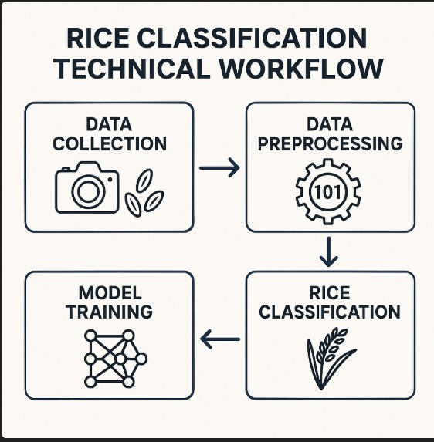

**Table-1 : Components & Technologies:**

|  |  |  |  |
| --- | --- | --- | --- |
| **S.No** | **Component** | **Description** | **Technology** |
|  | User Interface | Multilingual field app | Flutter + TEnsorFlow.js |
|  | Application Logic-1 | Spectral data augmentation | Python (Albumentations) |
|  | Application Logic-2 | Transfer Learning service | PyTorch Lightning (EfficientNet-B4) |
|  | Application Logic-3 | Geo-tagged data sync | Firebase GeoFire |
|  | Database | Rice genetic metadata | MongoDB Atlas |
|  | Cloud Database | Farmer transaction records | AWS Aurora |
|  | File Storage | Hyperspectral image repository | Google Cloud TPU Buckets |
|  | External API-1 | Grain market price API | GrainChain Price Index |
|  | External API-2 | Satellite imagery API | Sentinel-2 Hub |
|  | Machine Learning Model | Rice varietal transformer | Vision Transformer (Vit-L16) |
|  | Infrastructure (Server / Cloud) | Distributed training platform | AWS SageMaker + Jetson Nano edge nodes |

**Table-2: Application Characteristics:**

| **S.No** | **Characteristics** | **Description** | **Technology** |
| --- | --- | --- | --- |
|  | Open-Source Frameworks | Transfer learning ecosystem | HuggingFace, OpenMMLab |
|  | Security Implementations | GDPR-compliant farmer data | Homomorphic Encryption(SEAL) |
|  | Scalable Architecture | Handles 1M+daily field queries | AWS Lambda + Cloudflare Workers |
|  | Availability | 99.99% uptime during harvest | Multi-cloud failover |
|  | Performance | 92% accuracy on 120+ rice varieties | Quantized ViT + Knowledge Distillation |

**References:**

[**https://c4model.com/**](https://c4model.com/)

[**https://developer.ibm.com/patterns/online-order-processing-system-during-pandemic/**](https://developer.ibm.com/patterns/online-order-processing-system-during-pandemic/)

[**https://www.ibm.com/cloud/architecture**](https://www.ibm.com/cloud/architecture)

[**https://aws.amazon.com/architecture**](https://aws.amazon.com/architecture)

[**https://medium.com/the-internal-startup/how-to-draw-useful-technical-architecture-diagrams-2d20c9fda90d**](https://medium.com/the-internal-startup/how-to-draw-useful-technical-architecture-diagrams-2d20c9fda90d)